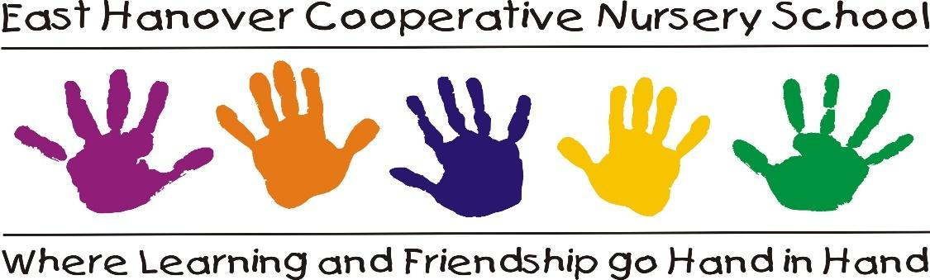

NEW LUNCH BUNCH PROGRAM!
INTRODUCTION

The East Hanover Cooperative Nursery School is now offering a Lunch Bunch program in addition to the existing 3’s class. The teacher is Jennifer Knapp. Jennifer earned her Associate’s degree from Essex County College in Early Childhood Education, and a Bachelor’s degree in General Humanities from Montclair State University. Previously, Jennifer has been working as a Substitute Teacher and as an Enrichment Teacher in local school systems.

OBJECTIVE
Lunch Bunch will be offered only to enrolled students as an optional class for an additional fee. It will offer children an opportunity to play, eat lunch, and learn. Children will bring their lunch from home (PLEASE NOTE: Lunch must be Tree Nut and Peanut Free!) It will be held Wednesdays from 12:00pm to 1:00pm.

PHILOSOPHY
Lunch Bunch is an extension of the classroom experience. It will focus on explorative learning through fun activities. Eating lunch together will offer a new socialization experience for the children. The Lunch Bunch schedule then consists of gross and fine motor play either outdoors or indoors, depending on the weather. It will be a fun time to eat lunch, read a story, or make a craft. Parents may also be invited to join the Lunch Bunch sessions on occasion.
ACTIVITIES
The activities in the Lunch Bunch will be carefully selected for three year olds. The activities will be theme-based and follow a message that we will be discussing each week. For example, the winter theme could cover snowflakes, hibernation, or winter holidays. Other topics will include natural sciences, occupations, and animals to name a few. Some activities will be individual crafts, and there will also be group activities such as story time and creative builders. In spring we plan to start an outdoor garden and discuss plant life and insects.

